NAME : MD RAFIQUE ANSARI AGE: 58 YRS/ M
Refd. By DR.: AIIMS DATE OF REPORT : 7 December 2025

================================================================REPORT OF M.R.I. SCREENING OF CERVICAL & DORSAL SPINE

Images are acquired in limited sections.
FINDINGS:
Technique: Multiplanar, multisequence MRI of the cervical and dorsal spine performed. Sagittal images obtained.

Findings:
Cervical Spine:
- C5–C6: Disc bulge noted with anterior thecal sac compression. Spinal canal diameter measures 9.3 mm on sagittal view (suggestive of canal narrowing).
- C7–T1: Disc bulge noted with anterior thecal sac compression.
- C3, C4, C5 & C6: Mild anterior osteophytes seen.
- Cervical cord signal intensity appears preserved.
- No evidence of intramedullary lesion or abnormal enhancement.
Dorsal Spine:
- Vertebral alignment maintained.
- Intervertebral discs appear normal.
- No disc bulge, herniation, or compressive lesion.
- Spinal canal and cord morphology within normal limits.

Impression:
- C5–C6 disc bulge with anterior thecal sac compression. Spinal canal narrowing (9.3 mm).
- C7–T1 disc bulge with anterior thecal sac compression.
- Mild anterior osteophytes at C3–C6.
- Rest Dorsal spine appears normal.

Recommendation:
- Suggested: Detailed Cervical Spine MRI study for further characterization of canal dimensions, disc pathology, and cord morphology.
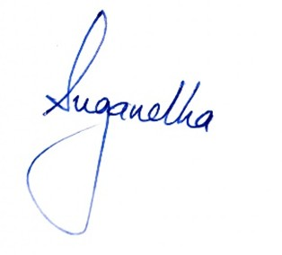
- Clinical correlation advised.

